**JOB LISTING TRACKER**

**A PROJECT REPORT**

***Submitted by***

**ADHESH M(220701012)**

***in partial fulfillment for the course***

**OAI1903 - INTRODUCTION TO ROBOTIC PROCESS AUTOMATION**

***for the degree of***

**BACHELOR OF ENGINEERING**

**in**

**COMPUTER SCIENCE AND ENGINEERING**

**RAJALAKSHMI ENGINEERING COLLEGE**

**RAJALAKSHMI NAGAR**

**THANDALAM**

**CHENNAI – 602 105**

**NOVEMBER 2024**

**RAJALAKSHMI ENGINEERING COLLEGE**

**CHENNAI - 602105**

**BONAFIDE CERTIFICATE**

Certified that this project report **“JOB LISTING TRACKER”** is the Bonafide work of **“ADHESH M (220701012)”** who carried out the project work for the subject OAI1903-Introduction to Robotic Process Automation under my supervision.

|  |
| --- |
| Mrs. J. Jinu Sophia**,** M.E., (Ph.D)  **SUPERVISOR**  Assistant Professor (SG)  Department of  Computer Science and Engineering  Rajalakshmi Engineering College  Rajalakshmi Nagar  Thandalam  Chennai - 602105 |
|  |

Submitted to Project and Viva Voce Examination for the subject OAI1903-Introduction to Robotic Process Automation held on __________.

**INTERNAL EXAMINER EXTERNAL EXAMINER**

**ACKNOWLEDGEMENT**

Initially we thank the Almighty for being with us through every walk of our life and showering his blessings through the endeavour to put forth this report. Our sincere thanks to our Chairman **Thiru. S. Meganathan, B.E., F.I.E.,** our Vice Chairman **Mr. M. Abhay Shankar, B.E., M.S.,** and our respected Chairperson **Dr. (Mrs.) Thangam Meganathan, M.A., M.Phil., Ph.D.,** for providing us with the requisite infrastructure and sincere endeavouring in educating us in their premier institution.

Our sincere thanks to **Dr. S. N. Murugesan, M.E., Ph.D.,** our beloved Principal for his kind support and facilities provided to complete our work in time. We express our sincere thanks to **Dr. P. Kumar, M.E., Ph.D.,** Professor and Head of the Department of Computer Science and Engineering for his guidance and encouragement throughout the project work. We convey our sincere and deepest gratitude to our internal guides, **Mrs. J. Jinu Sophia, M.E., (Ph.D)** Assistant Professor (SG) Department of Computer Science and Engineering for their valuable guidance throughout the course of the project. We are very glad to thank our Project Coordinator Professor, **Dr. N. Durai Murugan, M.E., Ph.D.,** Associate Professor and Mr. **B. Bhuvaneswaran, M.E.,** Assistant Professor (SG), Department of Computer Science and Engineering for their useful tips during our review to build our project.

**ADHESH M(220701012)**

**ABSTRACT**

The **Job Listing Tracker** is an RPA-based automation system designed to streamline the process of monitoring job openings across various online platforms. This system automates the retrieval of job listings from sources such as LinkedIn allowing users to track opportunities based on criteria like job title, location, and company. By leveraging UiPath for Robotic Process Automation (RPA), the solution efficiently navigates websites, extracts relevant job data, and presents users with a consolidated list of available positions.

The primary goal of this project is to minimize the manual effort involved in searching multiple job boards, ultimately saving time and enhancing the job search experience. The system incorporates web scraping techniques to gather job listings, applies filtering logic to refine results, and delivers updates to users in real-time. Additionally, the Job Listing Tracker can store historical job data, enabling users to analyze trends in job availability and tailor their applications accordingly.

This project not only showcases the potential of RPA for automating repetitive tasks but also emphasizes the practical application of UiPath in aggregating and comparing job opportunities across diverse platforms. This approach significantly improves user experience and operational efficiency for individuals seeking their next career move.

**TABLE OF CONTENTS**

**CHAPTER NO. TITLE PAGE NO.**

**ABSTRACT iv**

**LIST OF FIGURES vi**

**LIST OF ABBREVIATIONS vii**

**1. INTRODUCTION 8**

1.1 GENERAL 8

1.2 OBJECTIVE 9

1.3 EXISTING SYSTEM 9

1.4 PROPOSED SYSTEM 10

**2. LITERATURE REVIEW 11**

2.1 EFFICIENCY AND TIME REDUCTION 11

2.2 AUTOMATION TOOLS 12

2.3 DATA ACCURACY AND SECURITY 12

**3. SYSTEM DESIGN 12**

3.1 GENERAL 13

3.1.1 SYSTEM FLOW DIAGRAM 13

3.1.2 ARCHITECTURE DIAGRAM 14

3.1.3 SEQUENCE DIAGRAM 15

**4. PROJECT DESCRIPTION 16**

4.1 METHODOLOGIES 16

4.2 MODULES 17

**5. OUTPUT SCREENSHOTS 19**

**6. CONCLUSIONS 23**

**7. APPENDIX 25**

**8. REFERENCES 27**

**LIST OF FIGURES**

|  |  |  |
| --- | --- | --- |
| **Figure No** | **Title** | **Page No.** |
| **3.1.1** | **System Flow Diagram** | **13** |
| **3.1.2** | **Architecture Diagram** | **14** |
| **3.1.3** | **Sequence Diagram** | **15** |
| **5.1** | **Username** | **19** |
| **5.2** | **User Choice** | **19** |
| **5.3** | **Jobname input** | **20** |
| **5.4** | **Login Automation** | **20** |
| **5.5** | **Search for Job** | **21** |
| **5.6** | **Data extraction and storing in excel** | **22** |
| **5.7** | **Sending email** | **22** |
|  |  |  |

**LIST OF ABBREVIATIONS**

|  |  |
| --- | --- |
| **Abbreviation** | **Full Form** |
| **SMTP** | **Simple Mail Transfer Protocol** |
| **ERD** | **Entity Relationship Diagram** |
| **DFD** | **Data Flow Diagram** |
| **HR** | **Human Resources** |
| **API** | **Application Programming Interface** |
| **RE** | **Robotic Enterprise** |
| **RPA** | **Robotics Process Automation** |
| **CSV** | **Comma Separated Values** |

**CHAPTER-1**

**INTRODUCTION**

**1.1 GENERAL:**

The Job Listing Tracker is an innovative solution designed to simplify the process of monitoring and comparing job opportunities across various online platforms. Developed using Robotic Process Automation (RPA) tools like UiPath, this system automates the extraction of job listings from multiple job portals, enabling users to efficiently track job openings based on specific criteria such as job title, location, and company. By providing a consolidated view of available positions, the application minimizes the time and effort required for job searching, ensuring a more effective and user-friendly experience. This automation highlights the potential of RPA in enhancing job seekers' convenience and decision-making in today’s competitive job market.

**1.2 OBJECTIVE:**

The objective of the Job Listing Tracker project is to create an automated system that leverages Robotic Process Automation (RPA) tools like UiPath to streamline and optimize the process of comparing job listings across multiple job platforms. The system is designed to efficiently extract job data, analyze it, and present users with a comprehensive list of relevant job opportunities. By automating this process, the project aims to save users significant time and effort, eliminate the potential for manual errors, and deliver accurate, real-time results. Additionally, the project seeks to improve the overall user experience by offering a convenient and efficient solution while showcasing the versatility of RPA in addressing real-world challenges faced by job seekers.

**1.3 EXISTING SYSTEM:**

Currently, job seekers often face the challenge of manually searching for job listings across various platforms, such as LinkedIn. This manual process is not only time-consuming but also tedious, as users frequently have to search for the same position on multiple websites. The lack of automation leads to potential human error, with users possibly overlooking opportunities or failing to notice important details in job postings. Existing systems may provide limited job search functionalities, often restricted to specific websites or categories. Additionally, they may lack real-time updates, leading to incomplete information and missed opportunities. Many users also encounter complex interfaces and cumbersome manual data entry, resulting in a frustrating job search experience.

**1.4 PROPOSED SYSTEM:**The proposed Job Listing Tracker system aims to address the shortcomings of existing solutions by utilizing Robotic Process Automation (RPA) tools, specifically UiPath, to automate the job comparison process across multiple job platforms. This system will simplify and enhance the entire job search experience, enabling users to efficiently find suitable job openings with minimal effort and time. Key features of the proposed system include:

**CHAPTER-2**

**LITERATURE­_REVIEW**

A literature review on Job Listing Tracking and Robotic Process Automation (RPA) underscores the advancements and applications of technology in facilitating the job search process across multiple platforms. This section examines relevant research and technologies that have influenced the development of job tracking systems, along with the role of RPA in automating tasks such as data extraction and job comparison.

#### 1. **Job Listing Tracker Systems:**

The need for efficient job listing tracking has grown alongside the expansion of online job portals. Platforms like LinkedIn, Indeed, and Glassdoor have introduced features that allow users to search and compare job opportunities. However, many existing systems often focus on specific industries or geographic regions, limiting their scope. According to research by Kuo and Chen (2017), job search engines play a crucial role in enhancing convenience and reducing the effort required for job seekers to identify relevant openings across various platforms. Their findings indicate that users increasingly depend on these tools for streamlined job searches, highlighting the demand for comprehensive tracking solutions in the job market.

#### 2. **Robotic Process Automation (RPA) in Web Scraping:**

Robotic Process Automation (RPA) has gained traction for automating repetitive tasks such as data extraction, form submission, and workflow management. In job listing tracking, RPA can be utilized to automate the collection of job postings from various websites. Kumar et al. (2020) explore the application of RPA in improving operational efficiency by automating data collection tasks from diverse online sources. They argue that RPA minimizes human error and enhances productivity by enabling faster data retrieval and processing capabilities.

UiPath, a leading RPA tool, has been widely adopted in the industry for automating various business processes, including job data extraction. Singh and Gupta (2019) demonstrated how UiPath can effectively automate complex workflows, from data scraping to analysis, resulting in improved accuracy and reduced processing times. They noted that RPA tools like UiPath allow organizations to efficiently gather job listings, thereby facilitating quicker and more reliable job comparisons.

#### 3. **Challenges and Limitations:**

#### Despite the promising capabilities of job listing tracking systems and RPA, several challenges remain. One significant challenge is the variability of website structures, as different job portals often present diverse layouts and data formats, complicating the automation of data extraction. Rao and Sharma (2021) highlighted this issue, proposing the need for adaptable scraping techniques to accommodate various web designs.

#### 4. **Advances in Job SearchingAlgorithms:**

Recent advancements in algorithms for job matching have increasingly incorporated machine learning and artificial intelligence to enhance the user experience. Lee and Park (2019) introduced a model that merges machine learning with job tracking systems to not only match job listings but also predict trends in job availability based on historical data. Although such algorithms are still emerging in the realm of job listing tracking, their potential to optimize user recommendations is evident.

**CHAPTER-3**

**SYSTEM DESIGN**

**3.1.1 SYSTEM FLOW DIAGRAM**

The **System Flow Diagram** outlines the overall flow of data and processes in the system. It demonstrates how user inputs, system processing, and outputs interact.

**Description**:

* **Start:** The process begins when the user inputs job search criteria, including job title, location, and company preferences.
* **Parallel Activity:** The system concurrently scrapes job listings from multiple job portals, such as LinkedIn, Indeed, and Glassdoor, using a fork structure to ensure efficiency**.**
* **Data Processing:** Once the job listings are retrieved, the system cleans and structures the data to eliminate duplicates and irrelevant entries.
* **Comparison:** The processed data is analyzed to identify the most relevant job opportunities based on the user's criteria.
* **Result**: The best matches, along with essential details such as job title, company name, and application links, are compiled and returned to the user.
* **End:** The process concludes, providing users with an organized list of job opportunities that meet their specified requirements.

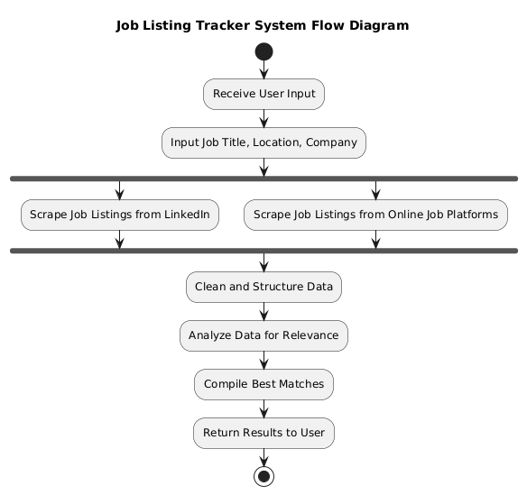

**Fig. 3.1.1. System Flow Diagram**

**3.1.2 ARCHITECTURE DIAGRAM**

The **Architecture Diagram** provides a high-level view of the system's structure and its components.

**Components**:

* **User**: Inputs job search criteria and views the results.
* **Client Interface:** Receives input from the user and triggers the automation process.
* **UiPath RPA Server:** Scrapes job listings from various online job platforms, processes the data, and compares the relevance of job opportunities.
* **External Job Portals:** Various online job platforms provide the job listing data.
* **Data Flow:** Ensures seamless movement of data from scraping to processing, comparison, and final result display.

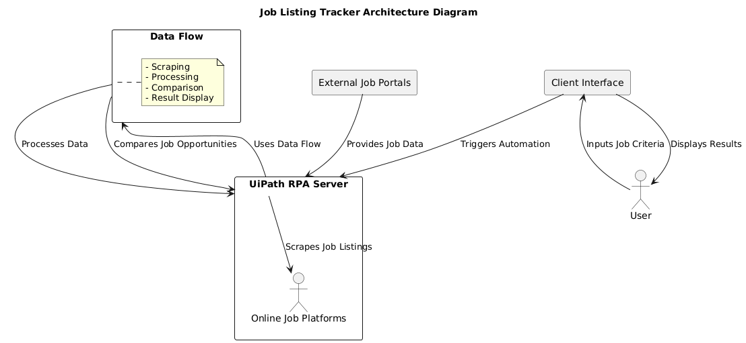

**Fig 3.1.2. System Architecture Diagram**

**3.1.3 SEQUENCE DIAGRAM**

The **Sequence Diagram** shows the interaction between actors (HR personnel) and the system components in a sequential manner.

**Steps**:

1. **User → Job Listing Tracker:**

* The user provides job search criteria (such as job title, location, and company preferences) to the Job Listing Tracker system. This is the initial input for the process.

1. **Job Listing Tracker → Online Job Platforms:**

* The Job Listing Tracker queries various online job platforms with the specified criteria to find available job listings.

1. **Online Job Platforms → Job Listing Tracker:**

* The online job platforms return the job listing information (this may include multiple job opportunities with details such as title, company, and location).

1. **Job Listing Tracker → Data Processing Module:**

* The Job Listing Tracker then processes the retrieved job listings to filter and structure the data accordingto user preferences.

1. **Data Processing Module → Job Listing Tracker:**

* The data processing module returns the filtered job listings back to the Job Listing Tracker for final review**.**

1. **Job Listing Tracker → User:**

* The Job Listing Tracker presents the filtered job opportunities to the user, providing the final output with relevant details.

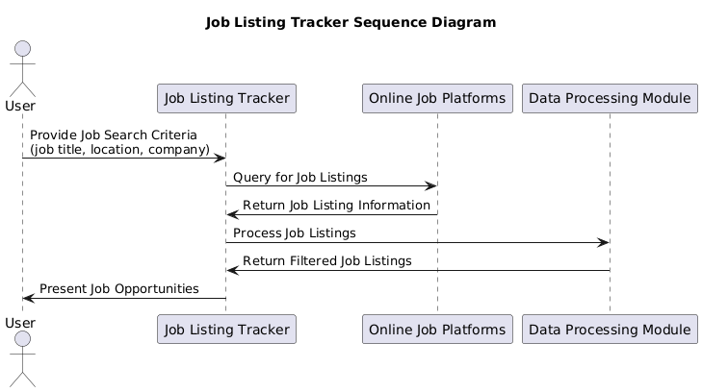

**Fig. 3.1.3. System Sequence Diagram**

**CHAPTER-4**

**PROJECT DESCRIPTION**

The **Job Listing Tracker** is an RPA-based automation project designed to simplify the job search process by comparing job listings across multiple online platforms, such as LinkedIn, Naukri, and Indeed. The system takes job search criteria (such as job title, location, and company) as input and automatically retrieves job listings from these platforms. It then filters, processes, and compares the listings to identify the most relevant job opportunities based on the user’s preferences.

Built using **UiPath RPA**, the system automates the process of querying multiple job platforms, collecting job data, and comparing the listings to provide the user with the best matches. This solution reduces the need for users to manually visit each job platform, saving time and effort. By automating these repetitive tasks, the Job Listing Tracker ensures that users receive timely, accurate, and relevant job recommendations, ultimately enhancing the job search experience.

**4.1 METHODOLOGIES**  
 The methodology employed for the Job Listing Tracker project follows the Robotic Process Automation (RPA) lifecycle, utilizing UiPath to automate the process of job data extraction and comparison. Here is the typical workflow:

**Step 1: Requirement Gathering**

* Collect user requirements, including the job titles, locations, and preferred companies for the job search. Determine which online job platforms to query for listings.

**Step 2: Process Design**

* Design the overall workflow, detailing the steps involved: gathering input, querying job platforms, processing job listings, and presenting the results.
* Utilize UiPath to create flowcharts and sequence diagrams, mapping out the activities and decision points involved in the process.

**Step 3: Data Extraction (Web Scraping)**

* Using UiPath, develop web scraping workflows to extract job listings and details from platforms like LinkedIn, Naukri, and Indeed. This involves automating browser actions, such as navigating to job sites, entering search criteria, and retrieving relevant job data.

**Step 4: Data Processing**

* After extracting job listings, process and filter the data to match the user’s criteria, using logical flows within UiPath to ensure the most relevant jobs are highlighted.

**Step 5: Result Presentation**

* Once the relevant job listings are identified, display the results to the user. This can be done through the UiPath interface or by generating a report or email notification summarizing the job opportunities.

**Step 6: Testing and Optimization**

* Conduct thorough testing of the entire workflow to verify that the web scraping and data processing are functioning correctly and yielding accurate results.
* Optimize the workflows for efficiency and robustness, ensuring they can adapt to changes in job platform layouts and user input variations.

**Step 7: Deployment and Maintenance**

* Deploy the solution for user access, enabling them to input job criteria and receive tailored job listings in real-time.
* Regularly maintain and update the system to ensure it remains effective, addressing any changes in the job platforms or user needs.

**4.2 MODULES**:

1. **Module 1: User Interface (UI)** **Module:**

#### Purpose: Collect user inputs such as job title, location, and preferred companies.

#### Features:

#### 1. Intuitive user interface, built using UiPath with input dialogs or a custom form.

#### 2. Input validation to ensure correct data is provided (e.g., valid job title, location).

#### Module 2: Data Extraction Module

#### Purpose: Extract job listings from external online platforms (e.g., LinkedIn, Naukri).

#### Features:

#### Web scraping capabilities to automate browsing, searching for jobs, and retrieving listings using UiPath activities like Get Text and Data Scraping.

#### Module 3: Data Processing Module

#### Purpose: Process and filter the job listings retrieved from multiple sources.

#### Features:

#### Comparison of job listings based on user criteria.

#### Identification of the most relevant job opportunities for the user.

#### Module 5: Data Storage Module (Optional)

#### Purpose: Store historical job listing data for analysis or future use.

#### Features:

#### Store job details and application statuses in a local or cloud database.

#### Perform periodic analysis to track job trends or user engagement.

#### Module 6: Logging and Reporting Module

#### Purpose: Track system activities and generate reports for users.

#### Features:

#### Maintain logs of user queries and corresponding job listings retrieved.

#### Generate reports (e.g., weekly summaries of job opportunities or performance metrics).

#### Module 7: Error Handling and Recovery Module

#### Purpose: Ensure the system can gracefully handle errors and recover from failures.

#### Features:

#### Mechanisms to retry failed operations or notify users when a platform is unreachable or an extraction fails.

#### Logging of errors for analysis and improvement of system reliability.

**CHAPTER-5**

**OUTPUT SCREENSHOTS**

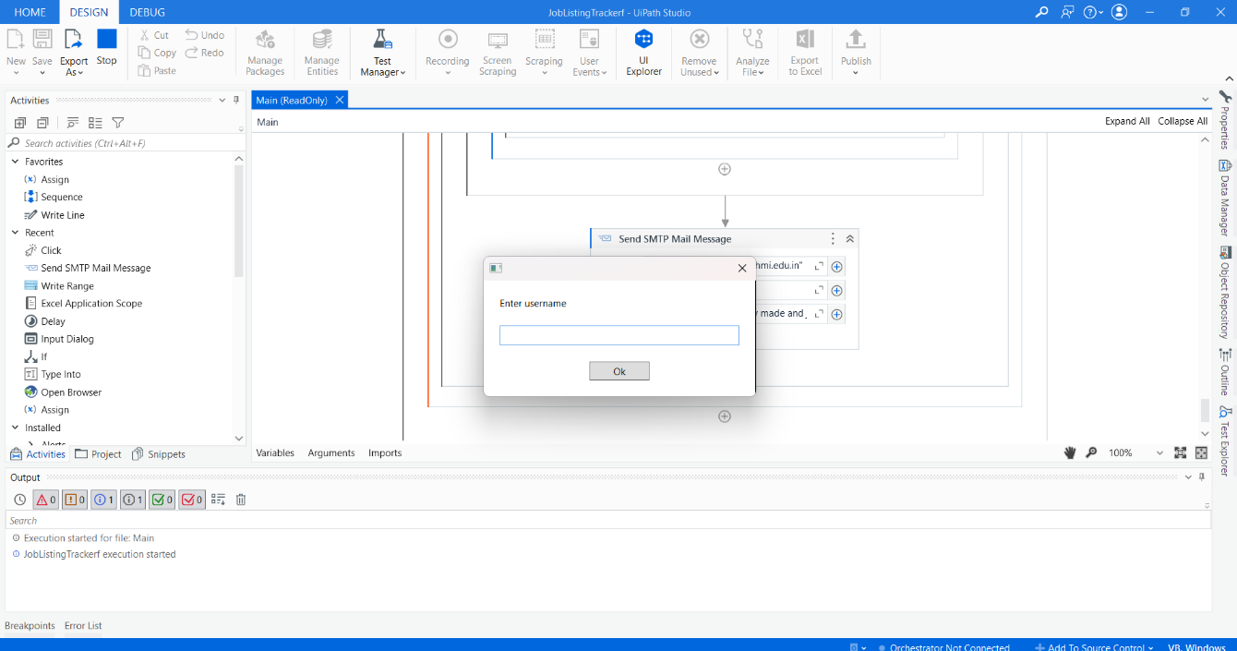

## **Fig. 5.1. Username**

This Figure contains the image of the bot asking for username.

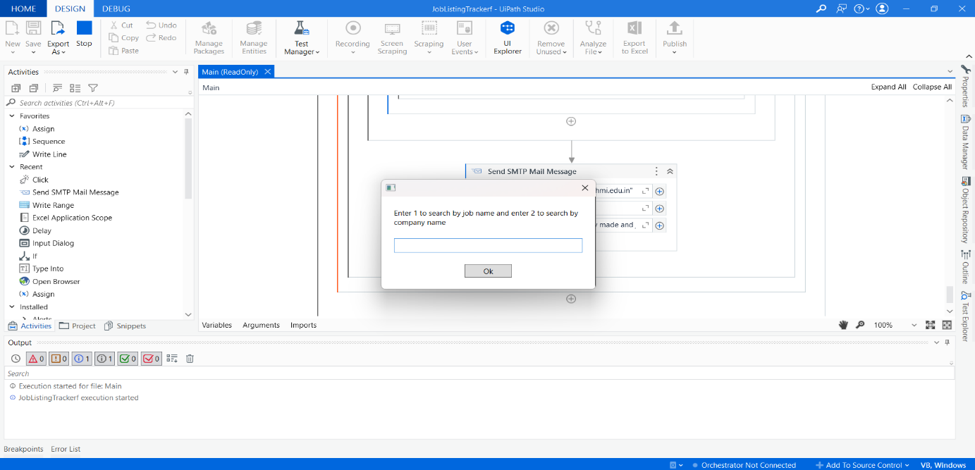

## **Fig. 5.2. User choice**

This Figure contains the image of the bot asking for the choic

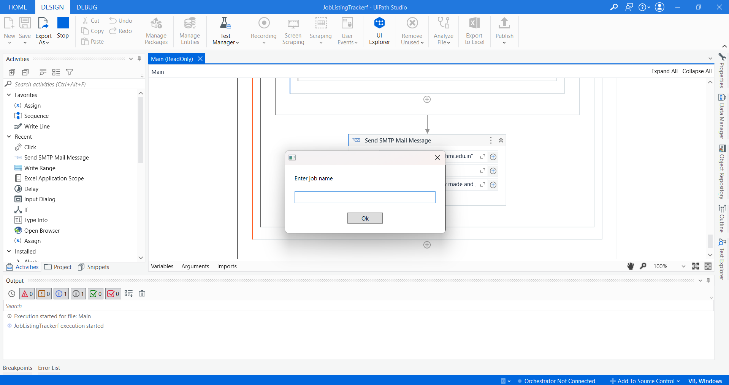

## **Fig. 5.3. Jobname input**

This Figure contains the image of the bot asking jobname.



## **Fig. 5.4. Login Automation**

This Figure contains the image of automating the login process.

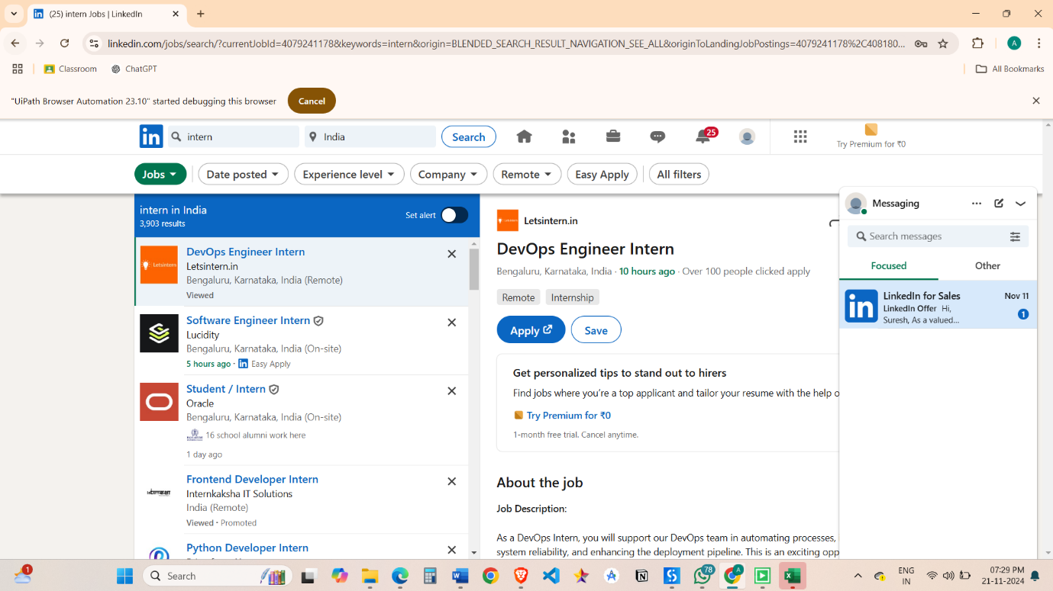

## **Fig. 5.5. Search for job**

This Figure contains the image of the bot searching the job details.

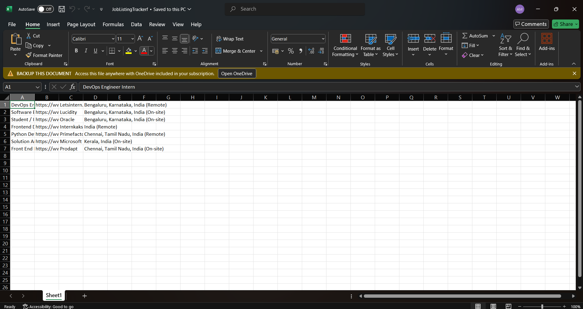

## **Fig. 5.6. Data Extraction and storing in excel**

This Figure contains the image of the data extraction and storage and organisation of data in an excel sheet.

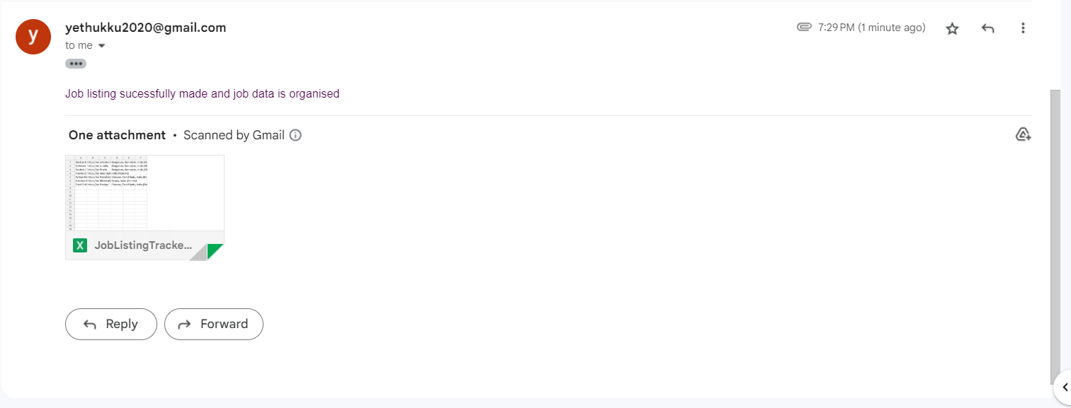

## **Fig. 5.7. Sending Email**

This Figure contains the image of the email sent with the excel file

**WORKFLOW SCREENSHOTS**

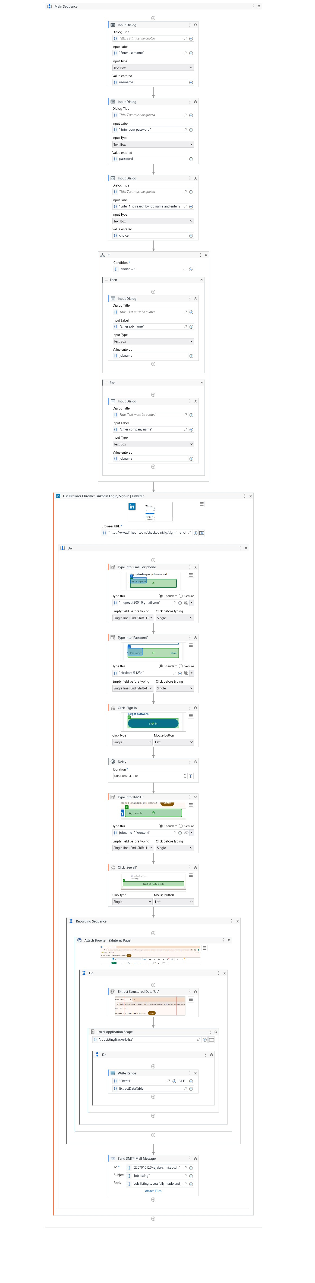





**CHAPTER-6**

**CONCLUSION**

The Job Listing Tracker effectively illustrates the practical application of Robotic Process Automation (RPA) in addressing the challenges of job searching. By automating the extraction and comparison of job listings from platforms like LinkedIn and Naukri, the system reduces the manual effort required to find suitable job opportunities, offering users a fast, efficient, and accurate solution.

Utilizing UiPath for web scraping, data processing, and decision-making creates a reliable and scalable system capable of adapting to various user needs. The project not only enhances user convenience by significantly decreasing the time spent on job searches but also lays the groundwork for future improvements, such as integrating additional job platforms, implementing historical data storage, and introducing advanced analytics features.

Overall, this project underscores the transformative potential of RPA in streamlining repetitive tasks, making it an invaluable tool for job seekers and organizations alike. By connecting users with multiple job platforms, the Job Listing Tracker delivers an innovative solution that improves user experience and facilitates effective career

**APPENDIX**

**Appendix A: Key Components of the System**

* **User Interface (UI):** A user-friendly interface designed to accept job criteria such as job title, location, and preferred companies. It displays the most relevant job listings.
* **Web Scraping/Automation Layer:** Uses UiPath to automate interactions with external job platforms (e.g., LinkedIn) for extracting job listing data.
* **Job Comparator Logic:** The logic implemented in UiPath workflows to filter and rank job listings based on user-defined criteria.

**Appendix B: Process Flow Summary**

1. Input Gathering: The user provides job criteria (title, location, companies) through the UI.
2. Data Retrieval: UiPath workflows scrape job listings from LinkedIn.
3. Job Comparison: Extracted data is processed to filter and rank job opportunities.

**Appendix C: Tools and Technologies**

* UiPath Studio: Primary tool for designing and executing RPA workflows.
* LinkedIn Website: Online platform used as a data source for job listing retrieval.

**Appendix D: Potential Enhancements**

1. AdditionalJob Platforms: Extend the system to include more jobportals for comparison (e.g., Indeed, Glassdoor).
2. Mobile App Integration: Develop a mobile app for better accessibility and user experience.
3. AI-Powered Insights: Incorporate AI models to predict job market trends or recommend suitable roles.

**REFERENCE PAPERS**

* 1. **UiPath Documentation**
  + Official UiPath documentation for RPA development, covering topics such as web scraping, automation workflows, and error handling.
  + [UiPath Documentation](https://docs.uipath.com)
* **LinkedIn**
  + Online professional networking platform used for extracting job listings and related data.
  + [LinkedIn Jobs](https://www.linkedin.com/jobs)
* **RPA Process Design Best Practices**
  + General guidelines and methodologies for designing robust RPA processes.
  + [RPA Best Practices](https://www.uipath.com/rpa/robotic-process-automation)
* **Web Scraping Techniques for UiPath**
  + Tutorials and examples of using UiPath to extract data from websites, including dynamic and static content.
  + [UiPath Academy](https://academy.uipath.com/)
* **Project Management Methodologies**
  + Insights into structuring and managing automation projects efficiently.
  + [Project Management Institute](https://www.pmi.org/)
* **Data Comparison Algorithms**
  + Concepts of logical decision-making for comparing data values programmatically.
  + [GeeksforGeeks](https://www.geeksforgeeks.org/comparison-algorithms)